**Camso Daily Monitoring Tool & Failed Jobs republish utility Deployment Note**



**Rajvina Yakub**

Version V1.0

**SUBMITTED BY**

**ITC INFOTECH INDIA LTD**

**Reviewed and Accepted by**

**Project/Program Manager Project Manager**



|  |
| --- |
| **Document Control** |

Document History

|  |  |  |  |  |
| --- | --- | --- | --- | --- |
| Version | Date | Maintainer | Reviewer | Description |
| 1 | 09/11/2018 | Rajvina Yakub |  | Deployment process for Daily monitoring tool & Failed Jobs republish utility |
|  |  |  |  |  |

|  |
| --- |
| **TABLE OF CONTENTS** |

Preface 5

1 Deploy Jar 5

2 Create Scheduler 6

**ITC Infotech**

**(**[**http://www.itcinfotech.com**](http://www.itcinfotech.com/)**)**

|  |
| --- |
| **Trademark Acknowledgement** |

Copyright© 2014 ITC InfoTech

All products or brand names used in this document are trademarks or registered trademarks of their respective companies.

ITC InfoTech shall not be liable for errors contained herein, or for consequential damages in connection with the furnishing, performance or use of the material. No part of this document may be reproduced or transmitted in any form or by any means, for any purpose, or translated to another language without the prior written consent of ITC InfoTech.

|  |
| --- |
| **Confidentiality Statement** |

By accepting this document the recipient agrees:

* To keep permanently confidential all information which it contains.
* To treat and retain as secret and confidential all information contained in this document or otherwise acquired by the receiving party from ITC InfoTech including, without prejudice to the generality of the foregoing, all handbooks, manuals, drawings, designs, specifications, charts, diagrams, tapes, disks, diskettes, and any other documents or materials containing such information.

# Preface

The purpose of this document is to describe deployment process for Daily monitoring tool.

# Deploy Jar

1. Stop Windchill
2. Copy the jar **camsoDailyMonitoring.jar** in Windchill Home.

From Windchill Shell extract the jar using below command

Jar xf camsoDailyMonitoring.jar

1. Start Windchill
2. Create a folder named **ITC_Backup\Daily_Monitroting_Reports** in **E** drive

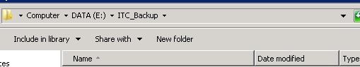

1. Edit monitor_01.itc in <Windchill_Home>\codebase\com\itcinfotech\monitor

and enter below property values

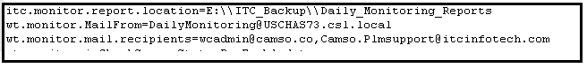

# Create Scheduler

1. Create scheduler for Daily Monitoring Tool

Go to Windows Task scheduler -> Click on Create Task

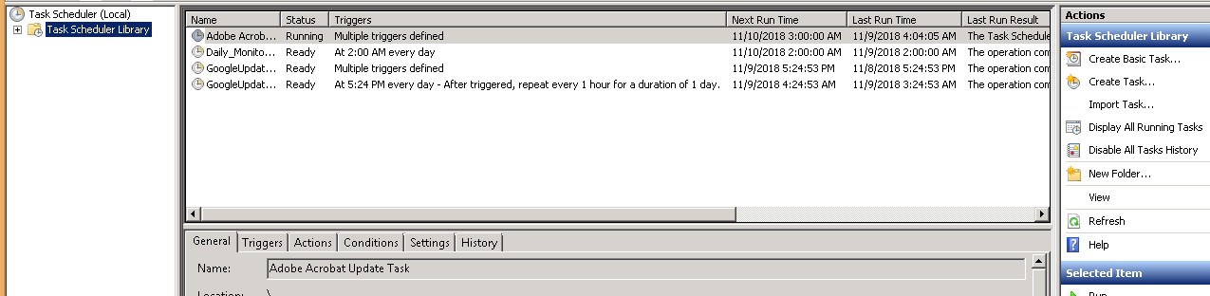

Enter Name for the Task

Select **Run whether user is logged on or not**

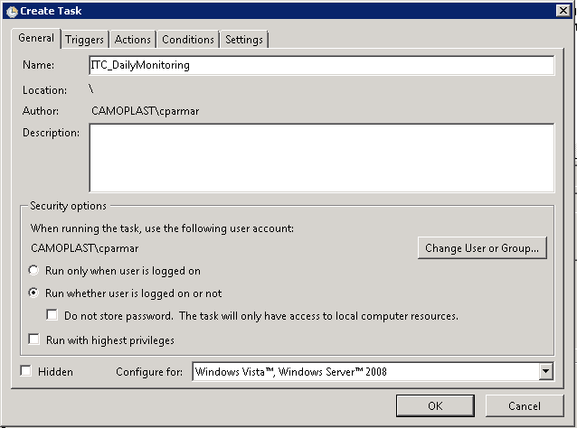

Click on New

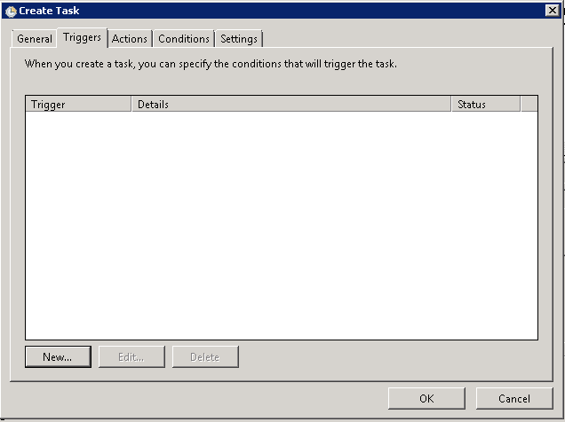

Set the time for Scheduler -> Run in every 30 minutes

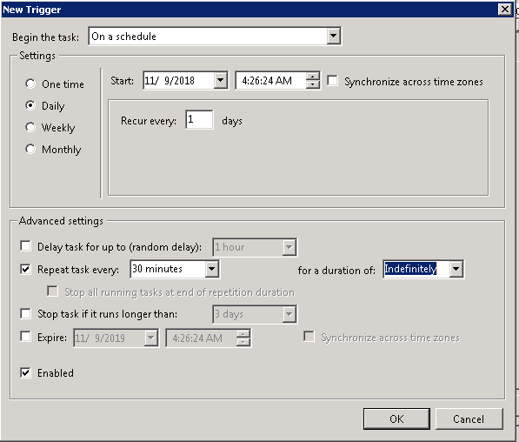

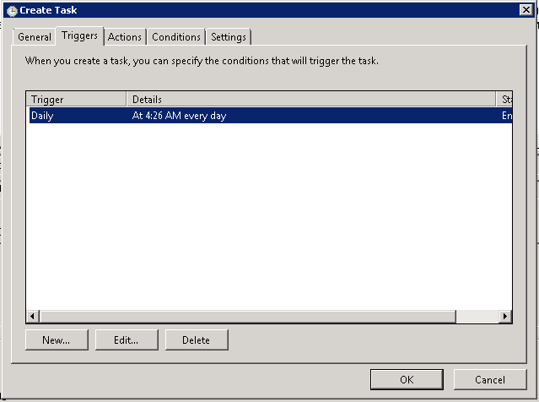

Go to Actions -> Click on New

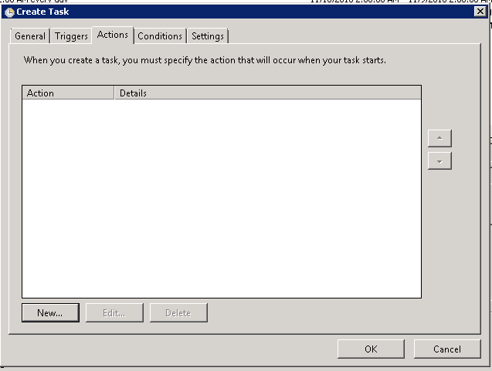

Browse to Daily Monitoring Batch file

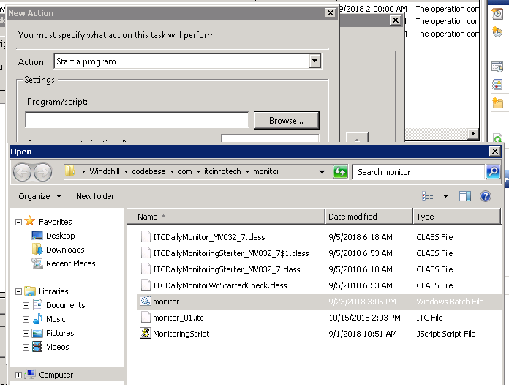

Click on OK

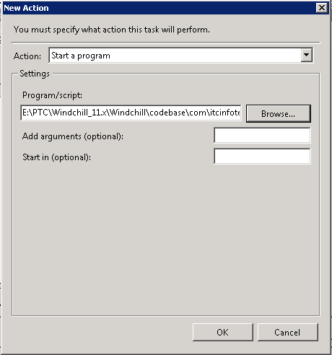

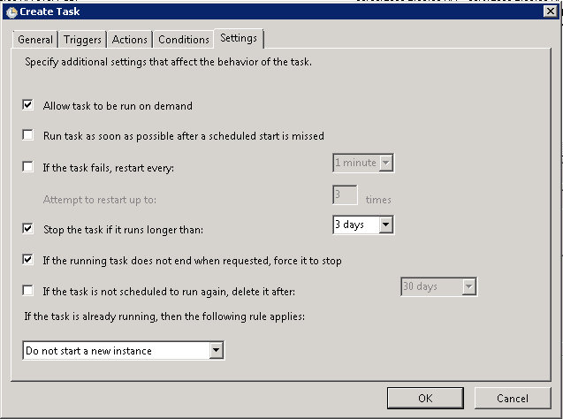

Click on Ok

Enter credentials for the account which will be used to run this scheduler

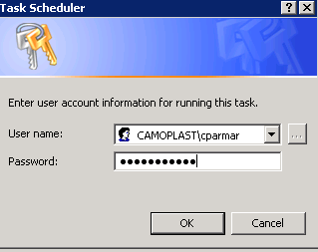

1. Create scheduler for Failed Jobs Republish Utility

Go to Windows Task scheduler -> Click on Create Task, Enter Name for the Task

Select Run whether user is logged on or not

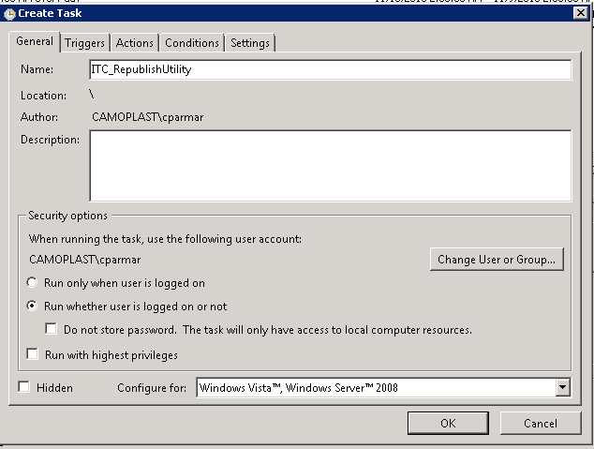

In Triggers -> Click on New

Set the time for Scheduler -> Run in every 6 Hours starting at 10:00PM EST

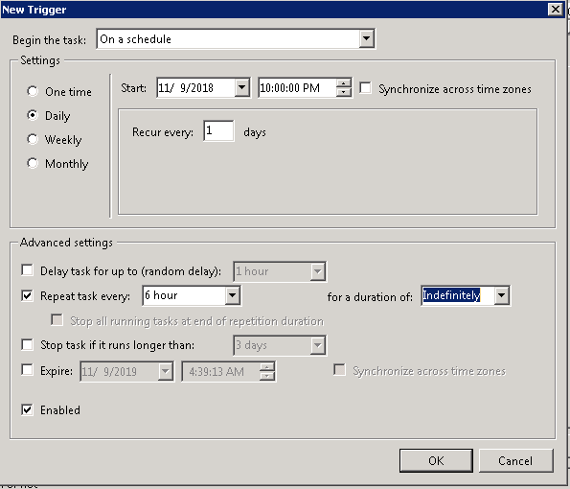

Go to Actions -> Click on New

Browse to Republish Utility Batch file

Click on OK

